COS10009 – Introduction to Programming
  - Learning Summary Report
  - Tran Quang Huy (106212636)

Self-Assessment Details
The following checklists provide an overview of my self-assessment for this unit.

 | Pass  (D) | Credit  (C) | Distinction  (B) | High Distinction  (A)
Self-Assessment (please tick) |  |  |  | A
Self-assessment Statement

 | Included (please tick)
Learning Summary Report | √
Test 1 and Test 2 are Compete in Ed | √
All Pass level tasks completed (including tutorial tasks) | √
Minimum Pass Checklist

 | Included (please tick)
All Credit Tasks are Complete in Ed | √
Minimum Credit Checklist, in addition to Pass Checklist

 | Included (please tick)
Distinction tasks (other than Custom Program) are Complete | √
Custom program meets Distinction criteria & Interview booked | √
Design report has structure chart and screenshots of program | √
Minimum Distinction Checklist, in addition to Credit Checklist

 | Included (please tick)
HD Project included | √
Custom project meets HD requirements | √
Minimum High Distinction Checklist, in addition to Distinction Checklist

Declaration
I declare that this portfolio is my individual work. I have not copied from any other student’s work or from any other source except where due acknowledgment is made explicitly in the text, nor has any part of this submission been written for me by another person.

Signature: 

Portfolio Overview
This portfolio includes work that demonstrates that I have achieve all Unit Learning Outcomes for COS10009 Unit Title to a High Distinction level.

My music player exceeds the Distinction level requirements in several keyways. At the Distinction level, the task requires reading album data from a file, displaying albums with artwork, allowing users to click albums to view tracks, and playing selected tracks via the Pygame mixer API. My implementation fulfils all these requirements completely.
Beyond the Distinction baseline, I have implemented all three suggested custom extensions. First, users can page through multiple pages of albums, with a dynamic page counter and navigation buttons that disable correctly at boundaries. Second, albums can be sorted by title or artist using a bubble sort algorithm implemented without Python's built-in sort functions, consistent with unit coding standards. Third, and most significantly, I implemented a full playlist system — users can add tracks from any album into a persistent playlist, reorder or remove entries, and play the entire playlist sequentially with automatic track advancement. This directly corresponds to the High Distinction extension described in the task sheet.
From a software design perspective, my code demonstrates strong separation of concerns across clearly named functions covering initialization, data loading, event handling, and rendering. I applied object-oriented design through the Track and Album classes and maintained consistent use of while loops in place of built-in iteration as required by the unit. Error handling is present throughout, including graceful fallback for missing image or audio files.
In summary, my music player satisfies all Distinction requirements and implements the playlist extension explicitly listed as a High Distinction custom program extension, justifying a High Distinction grade for this task.

Sort Albums:
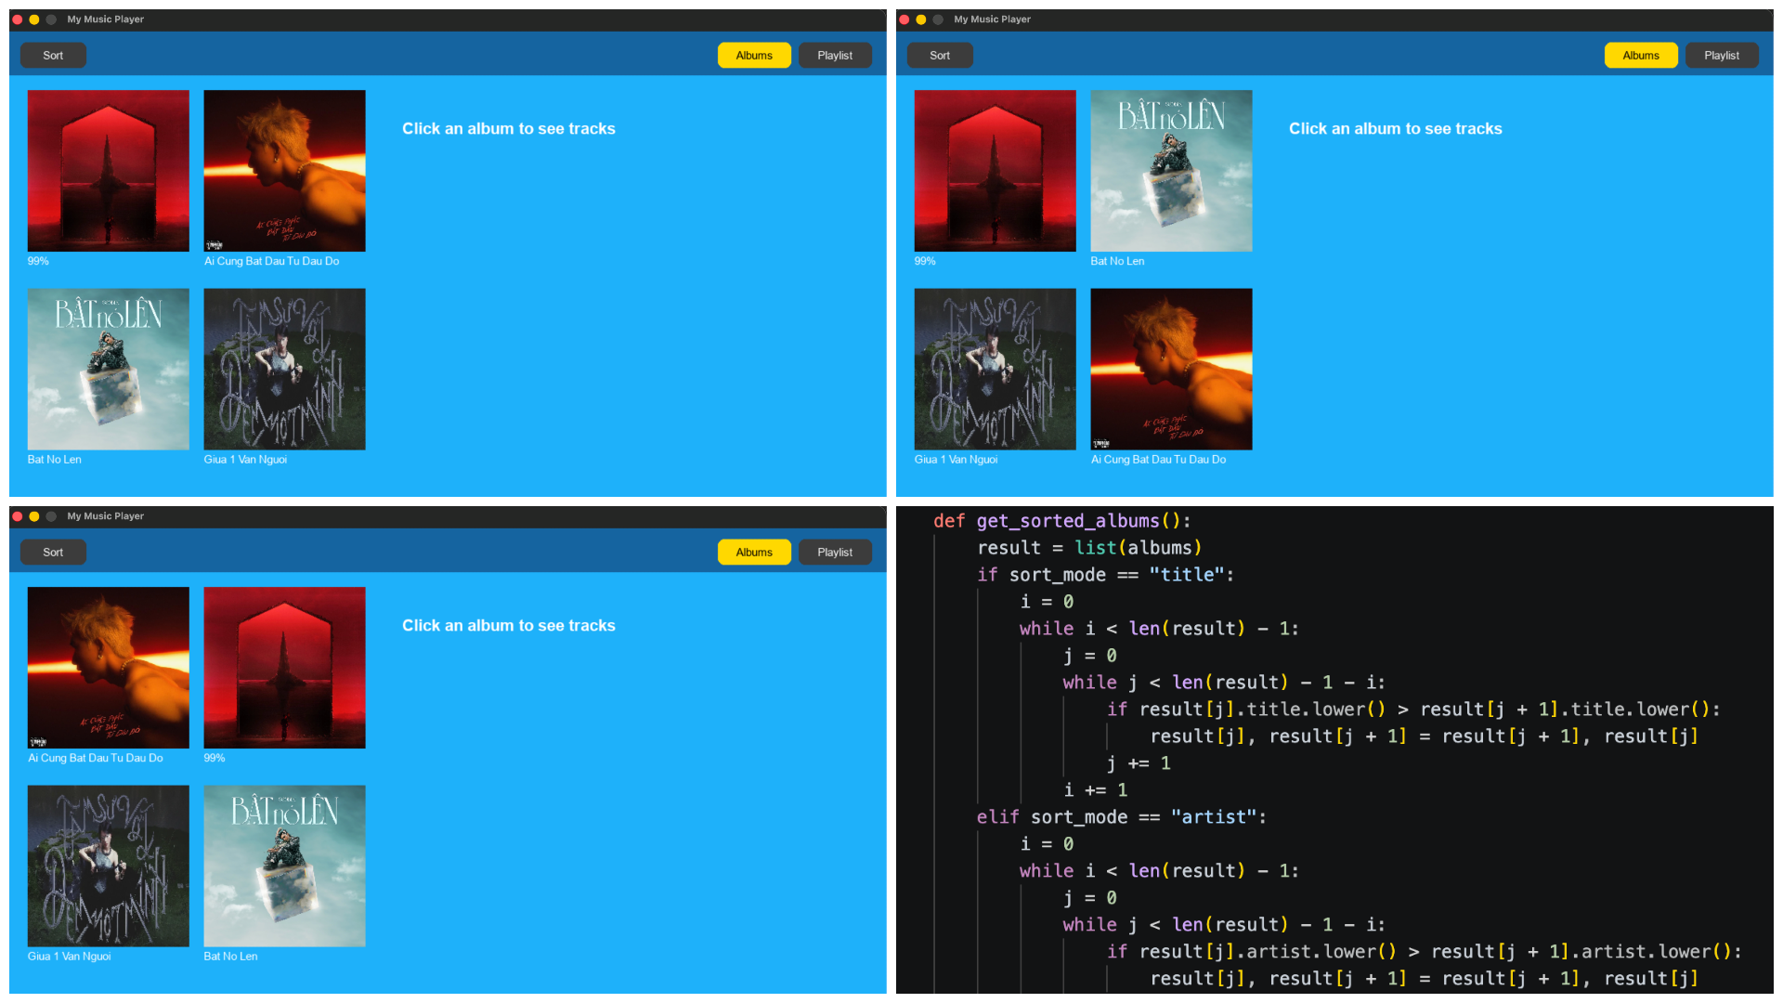
GUI with grid albums and artwork:
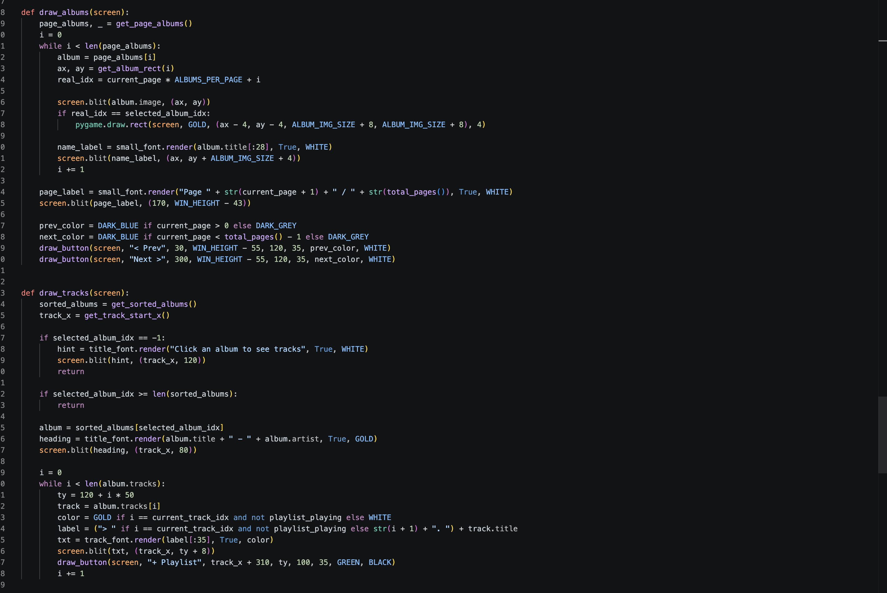

Get music played: 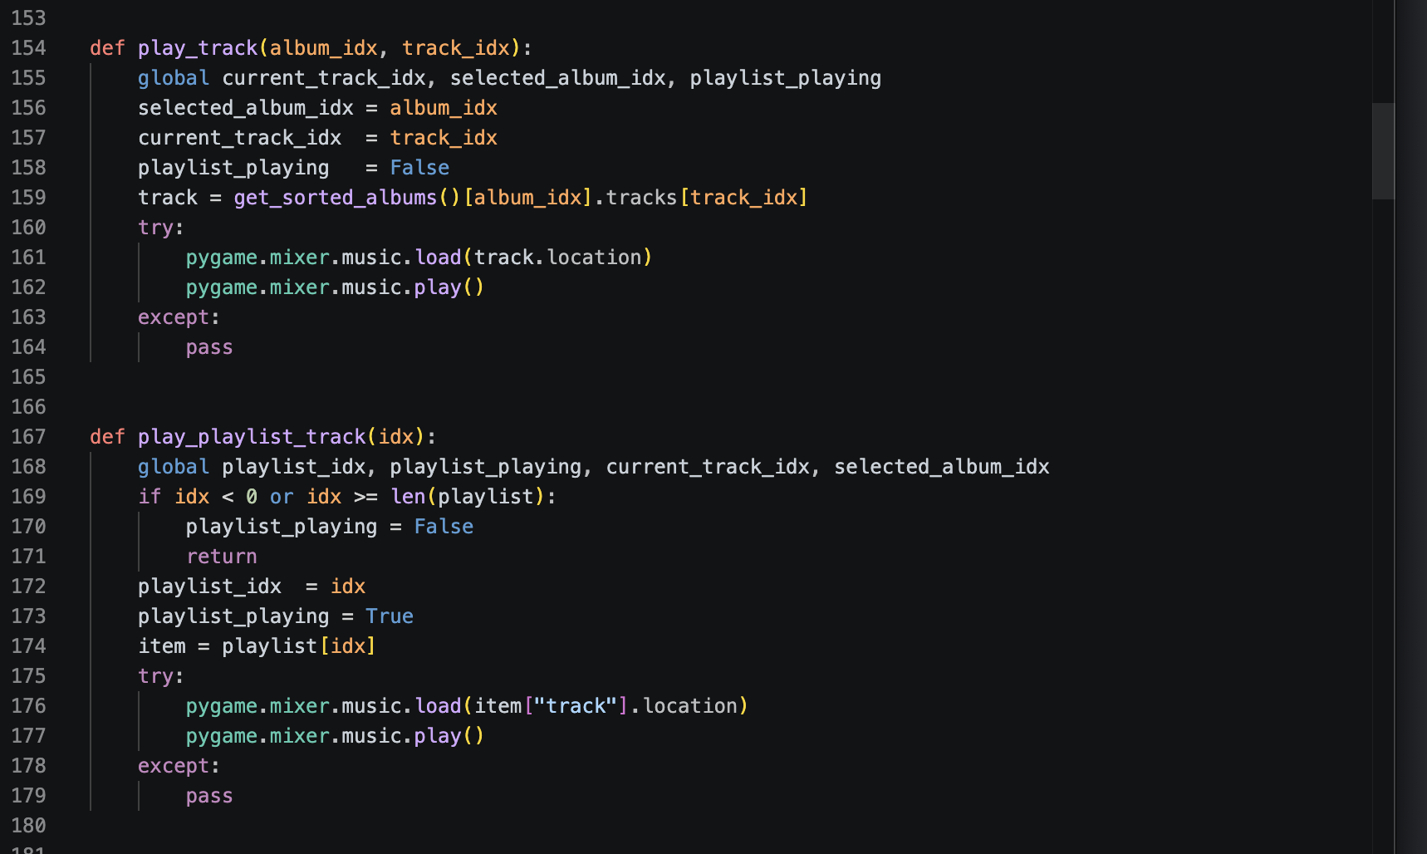
Reflection

The most important things I learnt:
I learned a lot from COS10009 – Introduction to Programming, not only about coding but also about thinking logically and solving problems step by step. One key thing I learned was structured programming, especially how to break problems into smaller parts using functions and procedures.
I also improved my skills in debugging and reading code, which helped me find errors and understand how programs work. In addition, I learned important concepts like arrays, functions, and basic data structures.
Overall, I learned what I expected and more. I now understand that programming is not just about writing code, but about logical thinking and problem-solving. This subject built a strong foundation for my future studies in IT.

The things that helped me most were:
The tutorial code from Ms Tram was the most helpful resource for me because it showed clear examples of how programming concepts are applied in practice. Instead of only learning theory, I could see how functions, loops, and conditions were used in real programs. This made it much easier for me to understand difficult topics.
Another reason why the tutorial code was useful is that I could modify and experiment with it. By changing small parts of the code and observing the results, I was able to learn more actively and improve my problem-solving skills. It also helped me understand common mistakes and how to fix them.
Overall, the tutorial code guided me step by step and gave me a strong foundation, especially when I was struggling with new concepts or assignments.

I found the following topics particularly challenging:
Designing the music player interface was the most difficult part for me because the design process was quite complex. I had to carefully determine the coordinates and grid layout for each element on the screen, which required a lot of precision and planning. Even small mistakes in positioning could affect the entire interface.
Another challenge was defining the mouse click areas correctly, especially when multiple elements were close together. This task required not only coding skills but also design thinking and understanding user interaction. Although it was difficult, it helped me gain a better understanding of how real applications are designed and built.

I found the following topics particularly interesting:
Coding with Pygame was the most interesting part for me because it allowed me to create simple games and interactive programs. As someone studying IT, I naturally enjoy games, so working with Pygame made learning more engaging and fun. Through this, I could see how concepts like loops, conditions, and functions are applied in real-time, making programming feel more practical, creative, and motivating.

I feel I learnt these topics, concepts, and/or tools really well:
I feel most confident with Pygame because I was able to apply programming concepts to create interactive programs. In particular, maze creation and maze search stood out to me as they required both logical thinking and practical implementation. I learned how to design maze structures, generate paths, and apply algorithms to find solutions from start to end. Overall, this experience helped me connect theory with practice and showed that I can apply concepts effectively in more complex programs.

I still need to work on the following areas:
I still need to improve my game design and planning, as I sometimes start coding too quickly without fully thinking about the structure, which makes it harder to manage more complex programs. I also need to work on writing cleaner and more efficient code, as my current code is sometimes not well-organized or reusable. In addition, I find it challenging to handle more complex logic and debugging in larger programs, so I need more practice to become faster and more confident in solving these issues. Overall, these are the key areas I need to focus on to further develop my programming skills.

This unit will help me in the future:
COS10009 provides a strong foundation that will support me in my future studies and career in IT. The concepts I learned, such as structured programming, problem-solving, and logical thinking, are essential for more advanced subjects like data structures, algorithms, and software development. In addition, working with Pygame and building small projects helped me understand how programming is applied in real-world scenarios.
The skills I developed, especially debugging, code organization, and breaking problems into smaller parts, will be very useful for my future career as a developer or data engineer. Overall, this unit has given me both a solid foundation and practical experience that I can continue to build on in the future.

If I did this unit again I would do the following things differently:
If I did this unit again, I would start assignments earlier and spend more time planning before coding to avoid rushing and improve my code quality. I would also practice more consistently instead of only focusing during deadlines, as this would help me understand concepts more deeply. In addition, I would focus more on designing the structure and logic of my programs before implementation, which would make coding easier and reduce errors. Overall, these changes would help me learn more effectively and achieve better results.

